**FPT ACADEMY INTERNATIONAL**



## FPT – APTECH COMPUTER EDUCATION

**NOBEL PRIZE**

|  |  |  |  |
| --- | --- | --- | --- |
| **Center Name** | | FPT – Aptech – HCM2  Address: 590 Cach Mang Thang Tam, District 3, Ho Chi Minh City | |
| **Instructor** |  | Ms. Le Mong Thuy |  |
| **Class** |  | T1.2302.E1 |  |
| **Group** |  | 1 |  |
| **Group members** | | **Name** | **Student ID** |
|  |  | Dinh Hoang Khanh Linh | Student23022004 |
|  |  | Nguyen Quoc Hoang | Student1316202 |
|  |  | Tran Bao Huy | Student1457510 |
| **Duration** | Start date | 23th May 2023 |  |
| End date | 23th June 2023 |  |

**This is to certify that**

**Mr.:**

Mrs. Dinh Hoang Khanh Linh

Mr. Nguyen Quoc Hoang

Mr. Tran Bao Huy

**has successfully designed & developed**

eProject: Nobel Prize website

**Submitted by:**

Dinh Hoang Khanh Linh

**Date of issue:**

**Authorized Signature:**

**TABLE OF CONTENTS**

Contents

FPT – APTECH COMPUTER EDUCATION 1

ACKNOWLEDGEMENT 4

SYNOSIS 4

PROBLEM DEFINITION 4

CUSTOMER'S REQUIREMENTS SPECIFICATIONS (CRS) 5

Business/Project Objective: 5

Input to the system: 5

Output from the system: 5

Process: 5

Expected delivery date: 21-June-2023. 5

List of deliverables: 6

Hardware/ Software Requirements: 6

SCOPE OF THE WORK (IN BRIEF) 7

ARCHITECTURE AND DESIGN OF THE SYSTEM 8

DIAGRAM OF THE WEBSITE 8

TASK SHEET REVIEW 1 10

SITE MAP 11

MOCK OF THE WEB SITE 12

1. Homepage 12

2. Winners and Nomination 13

3. News and Event 14

4. About Us 15

5. FAQ 16

6. Register 17

TASK SHEET REVIEW 2 18

WEBSITE DESCRIPTION 18

1. Homepage 18

2. Registration Form 20

3. About Us 22

4. Nomination 23

5. News 24

6. Events 26

7. FAQ 28

JAVASCRIPT DESCRIPTION 29

1. Slider JavaScript 29

2. Email JavaScript 31

3. Contact Form JavaScript 32

4. Register JavaScript 32

5. Button JavaScript 34

TASK SHEET REVIEW 3 35

# ACKNOWLEDGEMENT

On behalf of team members. I would like to thank everyone who supported my team to successfully complete this eProject report. Especially, our teacher, she has supported us a lot since we started studying at FPT Aptect. With this eProject, she guided us very meticulously, enthusiastically and strictly. With her guidance, we were able to successfully complete this project. Besides, I also want to thank all the team members, each of whom worked hard to complete the eProject in earnest during the month of working together. Finally, our group would like to say thank you to my classmates and family for sharing and creating for the group the best environment to focus on the project, motivating the members to achieve their goals.

# SYNOSIS

The goal of the eProject is that we need to create a website that meets all the requirements of the client, Nobel Prize. Nobel Prize is a website that aggregates all awards ever and updates the latest news on different disciplines like physics, chemistry, literature, medicine, peace from every country in the world. The goal of the website is to provide useful and latest industry information, as an educational information site that provides more knowledge for readers.

# PROBLEM DEFINITION

The Web site is to be created based on the following requirements.

1) The Home Page should be created with proper sections, graphics, and with a suitable logo.

2) Link on the Home Page must be included such as Home, About us, Gallery etc

3) The look and feel of the project must be made user friendly and uniformity in

the color combination must be maintained.

4) The site should include

- How and when Nobel Prize awards started

- Various fields in which Nobel prize is awarded

- Nominations in all field in all years

- Related news

- Related events

- Informative videos (related to the topic)

5) Each category mentioned above should brief user about respective topic.

6) Details of winners along with their career brief to be included.

7) Videos of important inventions should be included (size limit should be

considered)

8) Navigation of the project must be made smooth.

9) Site Map

10) Gallery

11) FAQs

# CUSTOMER'S REQUIREMENTS SPECIFICATIONS (CRS)

**Client:**

### Business/Project Objective:

Nobel Prize are awarded in the fields of Physics, Chemistry, Psychology, or Medicine, Literature, and Peace (Nobel characterized the Peace Prize as “to the person who has done the most or best to advance fellowship among nations, the abolition or reduction of standing armies, and the establishment and promotion of peace congresses”). In 1968, Sveriges Riksbank (Sweden’s central bank) funded the establishment of the Prize in Economic Sciences in Memory of Alfred Nobel, to also be administered by the Nobel Foundation. Nobel Prizes are widely regarded as the most prestigious awards available in their respective fields

The website is to be developed for the Windows Platform using HTML5, JavaScript and Geolocation. The site should work well in all leading browsers including Chrome, IE, Firefox etc.

### Input to the system:

* Winners, Nomination, News, Event, About Us, FAQ.
* Registration Form.

### Output from the system:

- Perform search based on: brand, product type, voltage, capacity...

- Display results for each type of product according to the search content.

- Display product information by price, specifications, brand, image, color, model...

- Display the special information of the product.

- Display products of the same type, same brand, and other related products.

- Display a button so that customers can download the product's catalog

- Customers can also download the price list of products on the website

- Site should be able to provide a brief introduction/history about the shop under the About Us page.

- The location of the shop under the Contact-Us page.

- Displays FAQ and allows users to email directly to the company.

### Process:

* + - * Validate data input from users.

### Expected delivery date: 21-June-2023.

### List of deliverables:

- Document Word, PDF.

- User Guide.

- Source code.

### Hardware/ Software Requirements:

* **For developer**

**Hardware**

* Intel Pentium 4 processor or higher
* 01 Gigabytes of RAM or higher

**Software**

* Windows 7 OS or higher
* Adobe Dreamweaver
* Web browsers such as IE, Chrome or Firefox are supporting HTML5, CSS3 and Javascript.
* **For web users**

**Hardware**

* Intel Pentium 4 processor or higher
* 512 Megabytes of RAM or higher

**Software**

* Windows XP OS or higher
* Web browsers such as IE, Chrome or Firefox are supporting HTML5, CSS3 and Javascript.

# SCOPE OF THE WORK (IN BRIEF)

After a long and detailed discussion, our group has decided to create a website contain the following webpages:

1. ***Homepage***: Contains picture of famous Nobel speeches, conference information and a link to the conference registration page, footer.
2. ***Winners***: Displays all awards and winners of all industries.
3. ***Nomination***: Display the nomination information and requirements for the categories.
4. ***News***: Display the latest news and announcements from the Nobel Prize.
5. ***Events***: Discover more about the events we hold around the world.
6. ***About Us***: Display the information of the company, and Map.
7. **FAQs**
8. ***Registration Form***: Allow users regist to join the conference.

# ARCHITECTURE AND DESIGN OF THE SYSTEM

# 

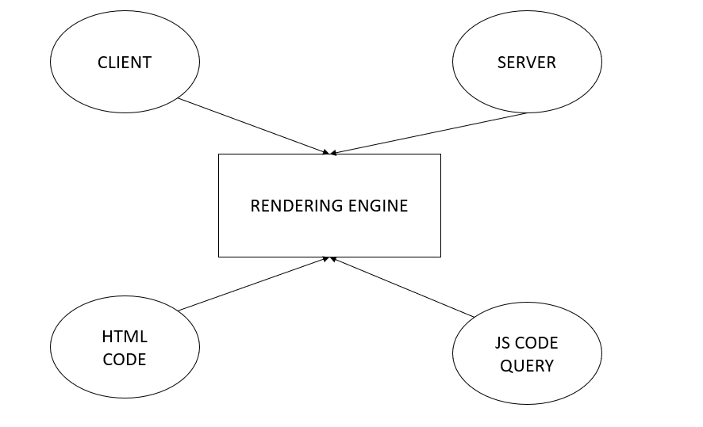

# DIAGRAM OF THE WEBSITE

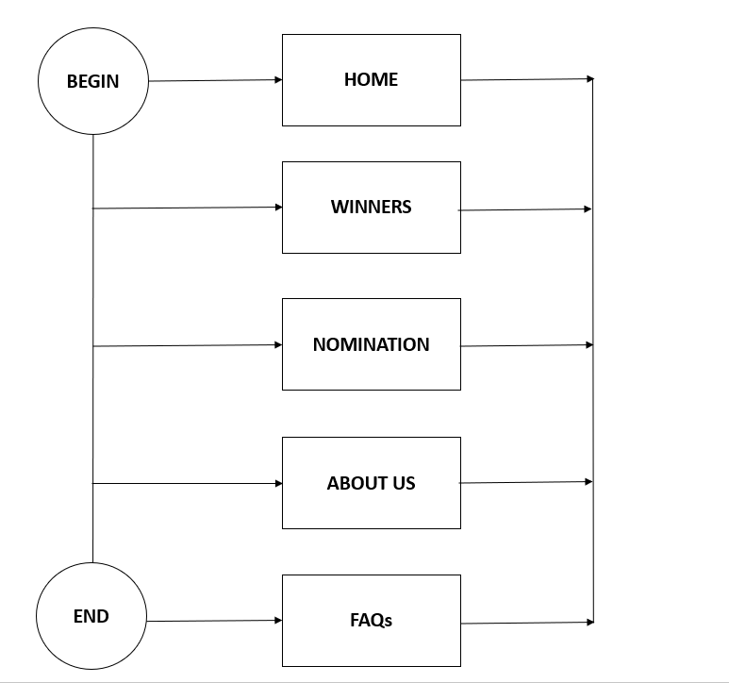



# TASK SHEET REVIEW 1

|  |  |  |  |  |  |  |  |
| --- | --- | --- | --- | --- | --- | --- | --- |
| **Project Ref. No.:**  **eP/Advertisement Portal Management**  **System/01** | | **Project Title:** | **Activity Plan Prepared By:** | **Date of Preparation of Activity Plan:** | | | |
| **Sr.**  **No.** | **Task** | **Actual**  **Start**  **Date** | **Actual Days** | **Team**  **Mate Names** | **Status** |
| 1 | Problem Statement | Nobel Prize | Linh | 23-May-23 | 1 | Linh | Completed |
| 2 | Analysis of Nobel Prize requirements about the website | 23-May-23 | 1 | Linh | Completed |
| 3 | The scope of the work (in brief) | 23-May-23 | 1 | Hoang | Completed |
| 4 | Architecture and design of the system | 23-May-23 | 1 | Hoang | Completed |
| 5 | Diagram of the website | 23-May-23 | 1 | Huy | Completed |
| 6 | Task Sheet | 23-May-23 | 1 | Huy | Completed |

|  |  |
| --- | --- |
| **Date:** | |
| Signature of Instructor:  **Ms. Le Mong Thuy** | Signature of Team Leader:  **Dinh Hoang Khanh Linh** |

# SITE MAP

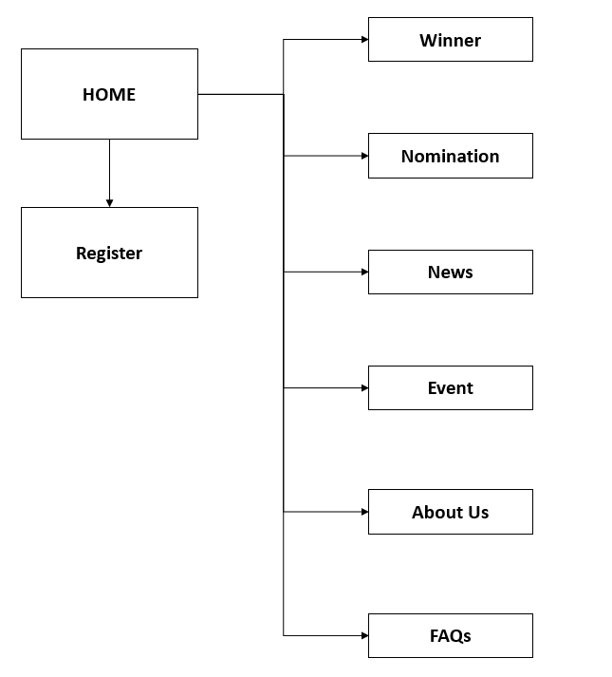

# MOCK OF THE WEB SITE

## Homepage

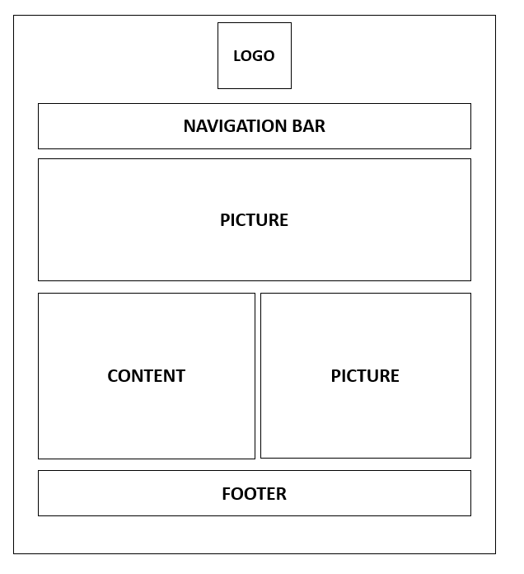

## Winners and Nomination

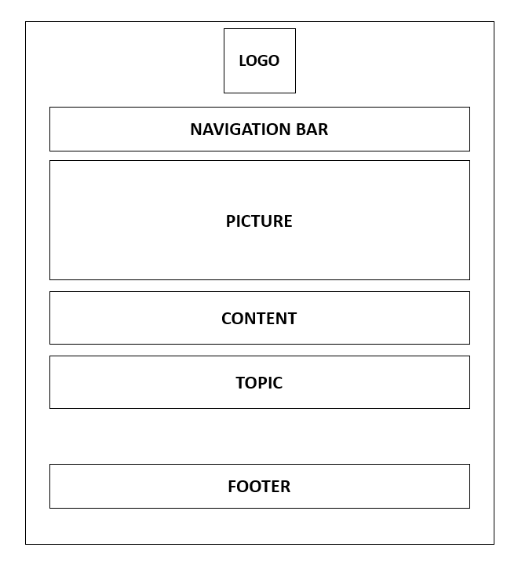

1. **News and Event**

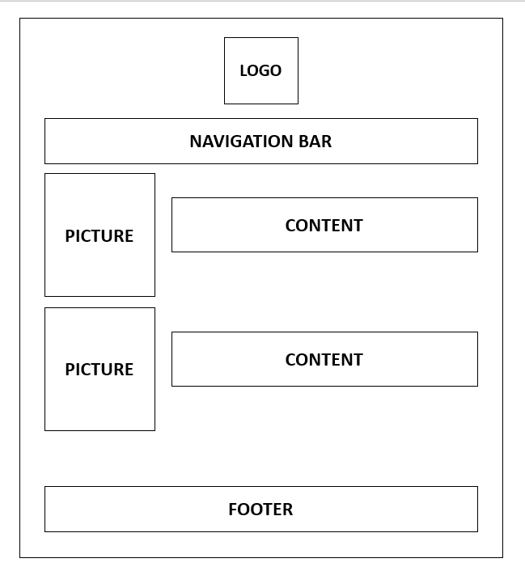

## About Us

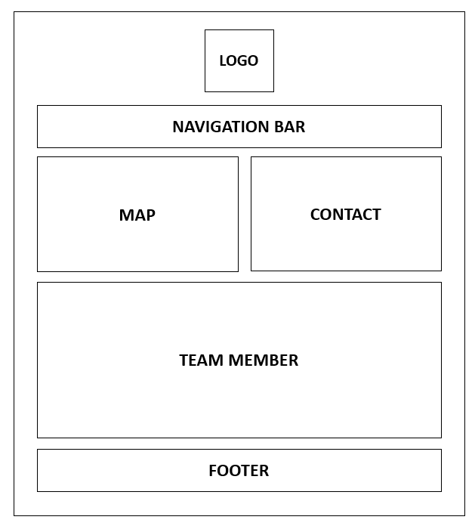

## FAQ

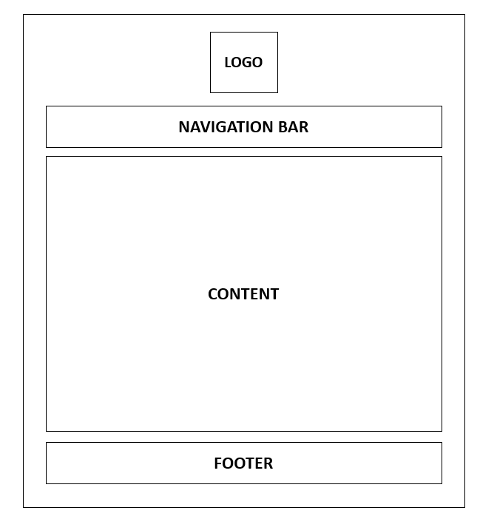

## Register

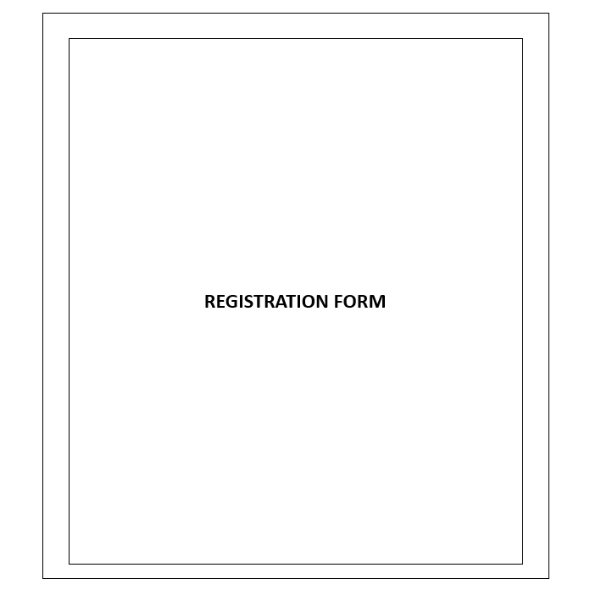

# TASK SHEET REVIEW 2

|  |  |  |  |  |  |  |  |
| --- | --- | --- | --- | --- | --- | --- | --- |
| **Project Ref. No.:**  **eP/Advertisement Portal Management**  **System/01** | | **Project Title:** | **Activity Plan Prepared By:** | **Date of Preparation of Activity Plan:** | | | |
| **Sr.**  **No.** | **Task** | **Actual**  **Start**  **Date** | **Actual Days** | **Team**  **Mate Names** | **Status** |
| 1 | Site Map | Nobel Prize | Linh | 23-May-23 | 1 | Linh | Completed |
| 2 | Mock of the website | 23-May-23 | 2 | Linh | Completed |
| 3 | Task sheet | 23-May-23 | 2 | Linh | Completed |

|  |  |
| --- | --- |
| **Date:** | |
| Signature of Instructor:  **Ms. Le Mong Thuy** | Signature of Team Leader:  **Dinh Hoang Khanh Linh** |

# WEBSITE DESCRIPTION

## 1. Homepage

a) Description

Home page displays following information:

- Slideshow banner

- Navigation Bar

- Registration Form

- Footer

b) Screenshot

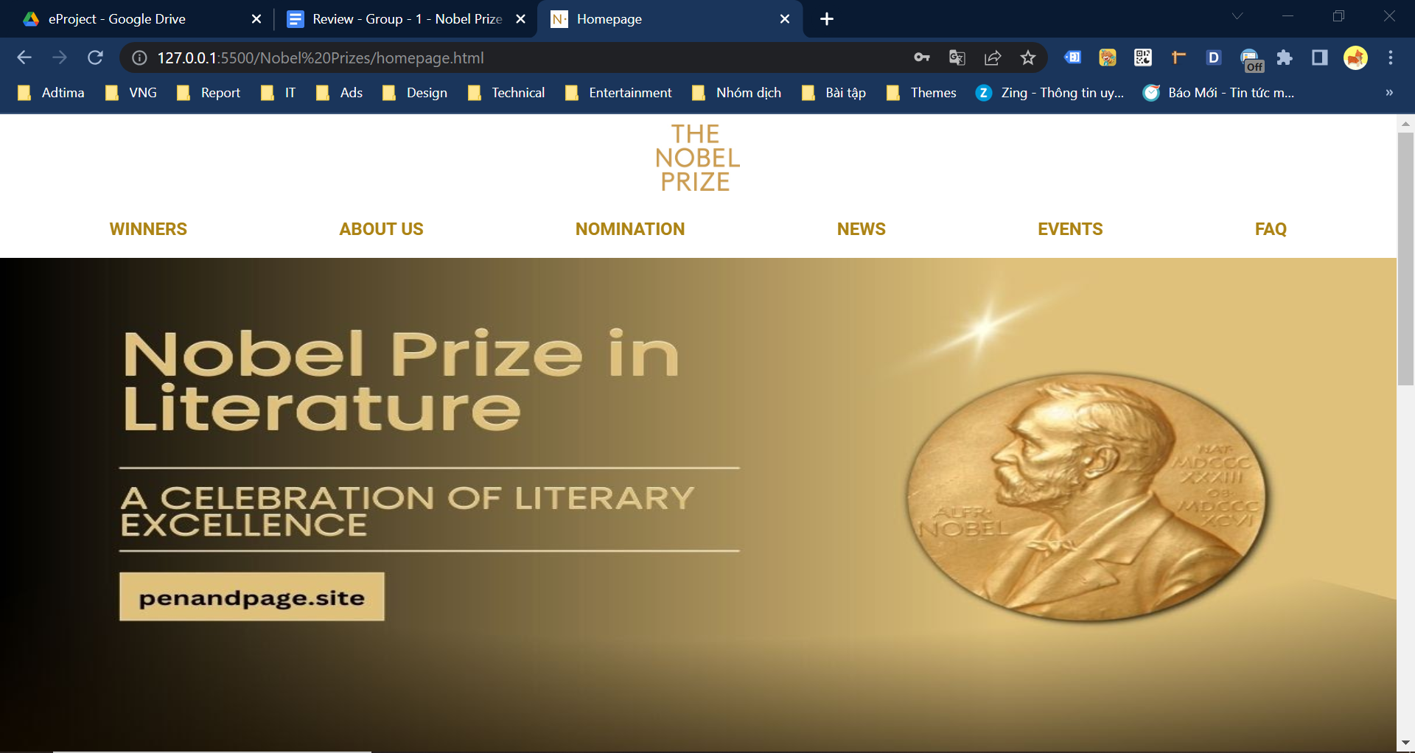

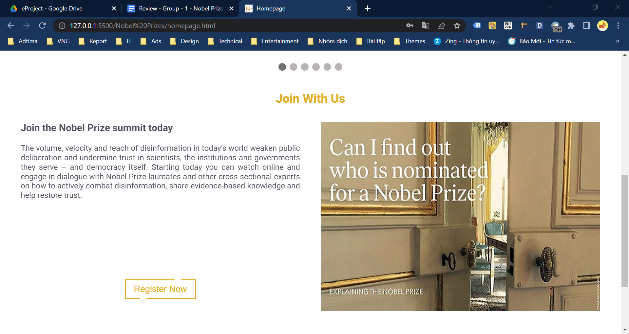

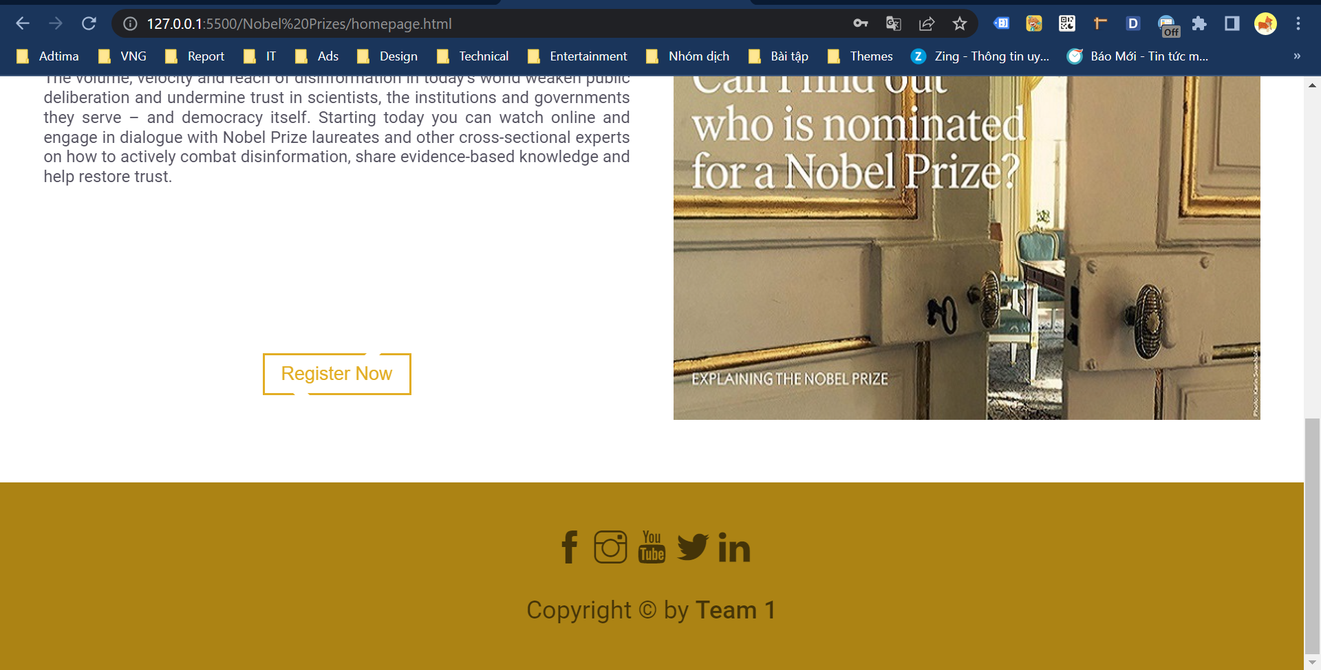

## 2. Registration Form

a) Description

This page displays following information:

- Personal Information

- Contact

- Security

b) Screenshot

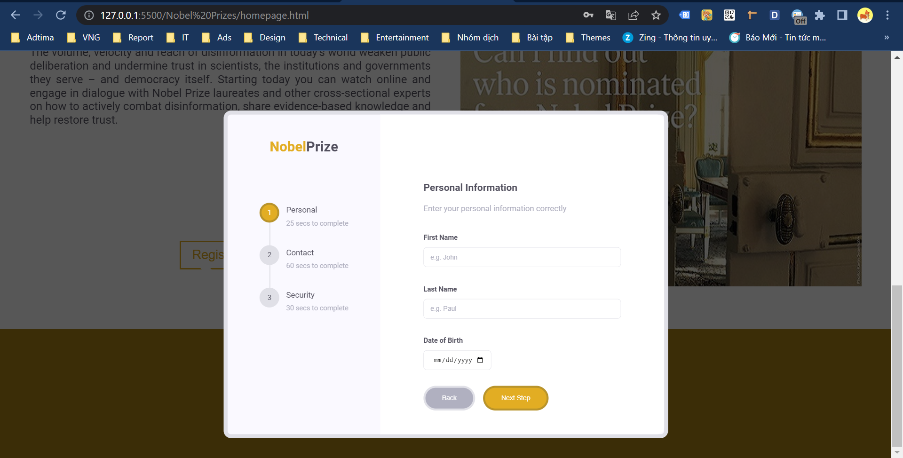

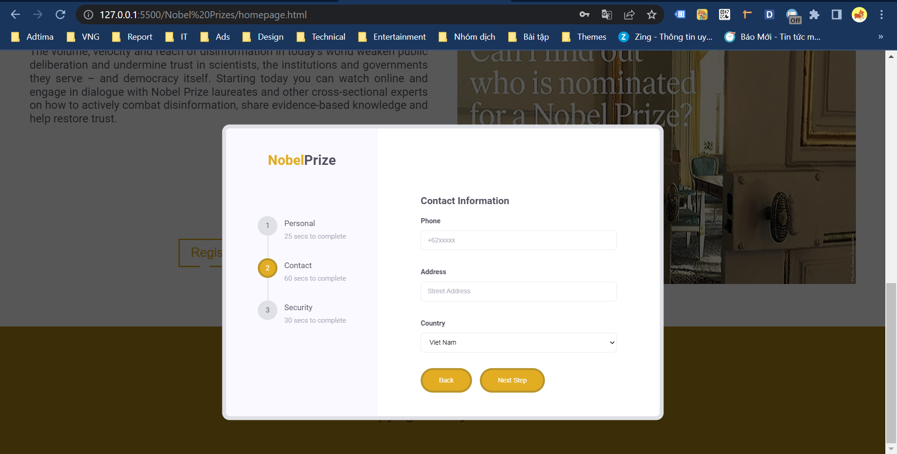

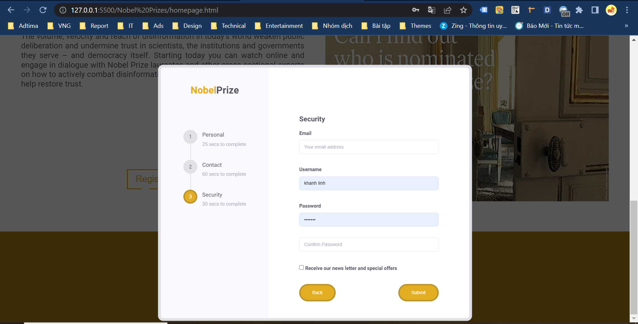

## 3. About Us

a) Description

The page displays following information:

- Location, Phone number, Email

- Customer’s Information

- Team members information

b) Screenshot

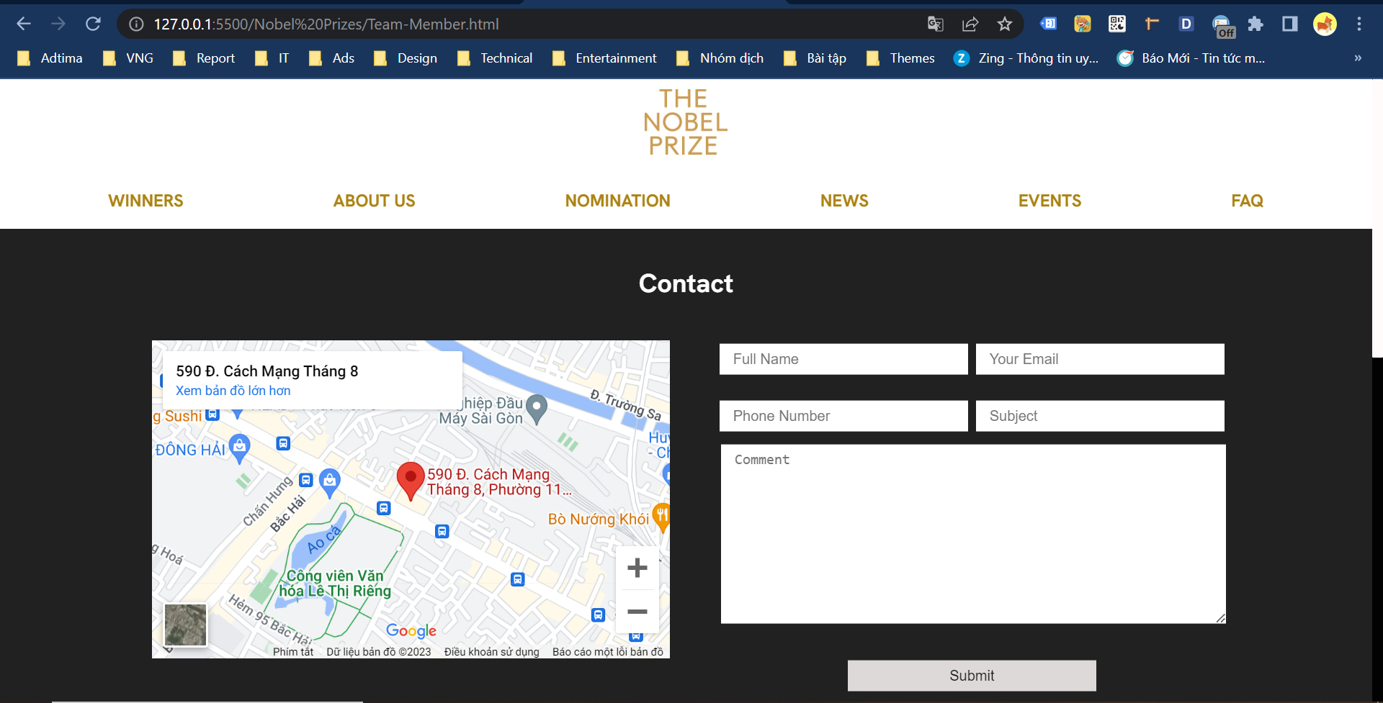

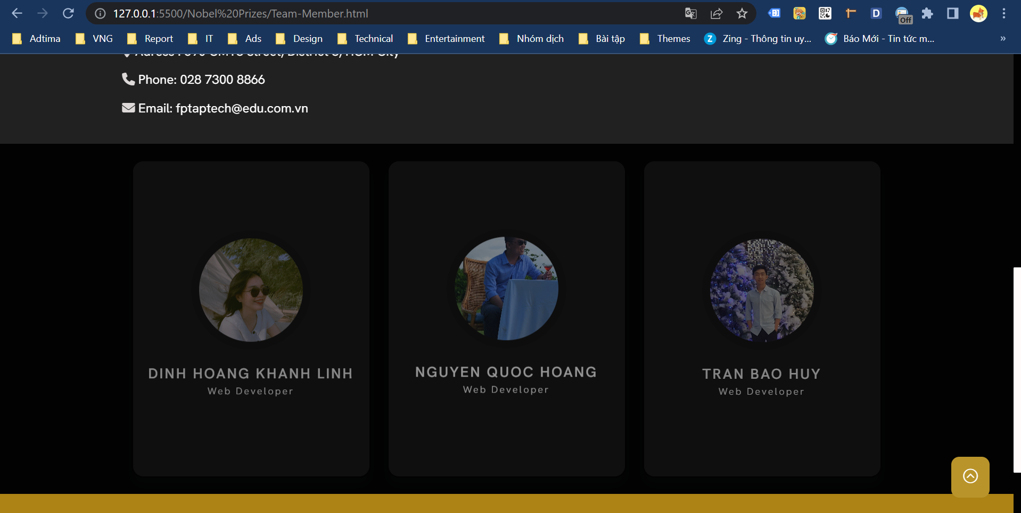

## 4. Nomination

a) Description

- This page displays information about the physics, chemistry, medicine, literature and peace prize.

b) Screenshot

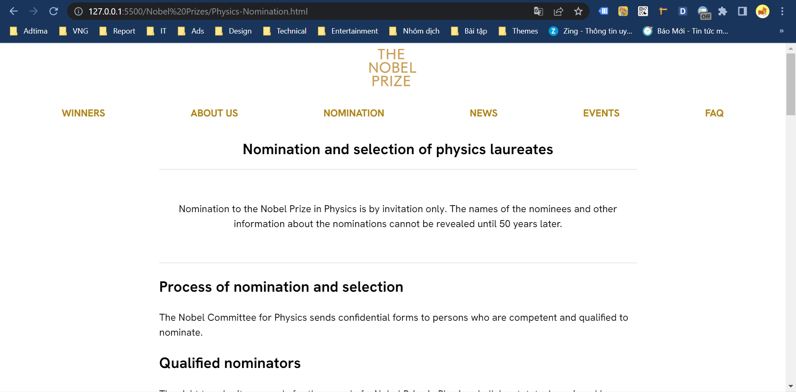

## 5. News

a) Description

This page displays information about news in physics, chemistry, medicine, literature, and peace.

b) Screenshot

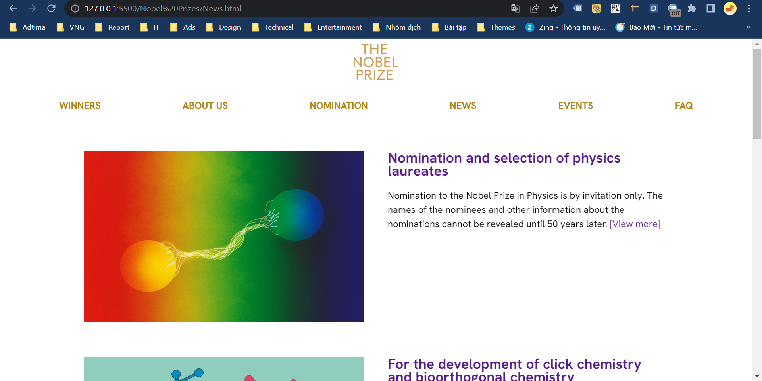

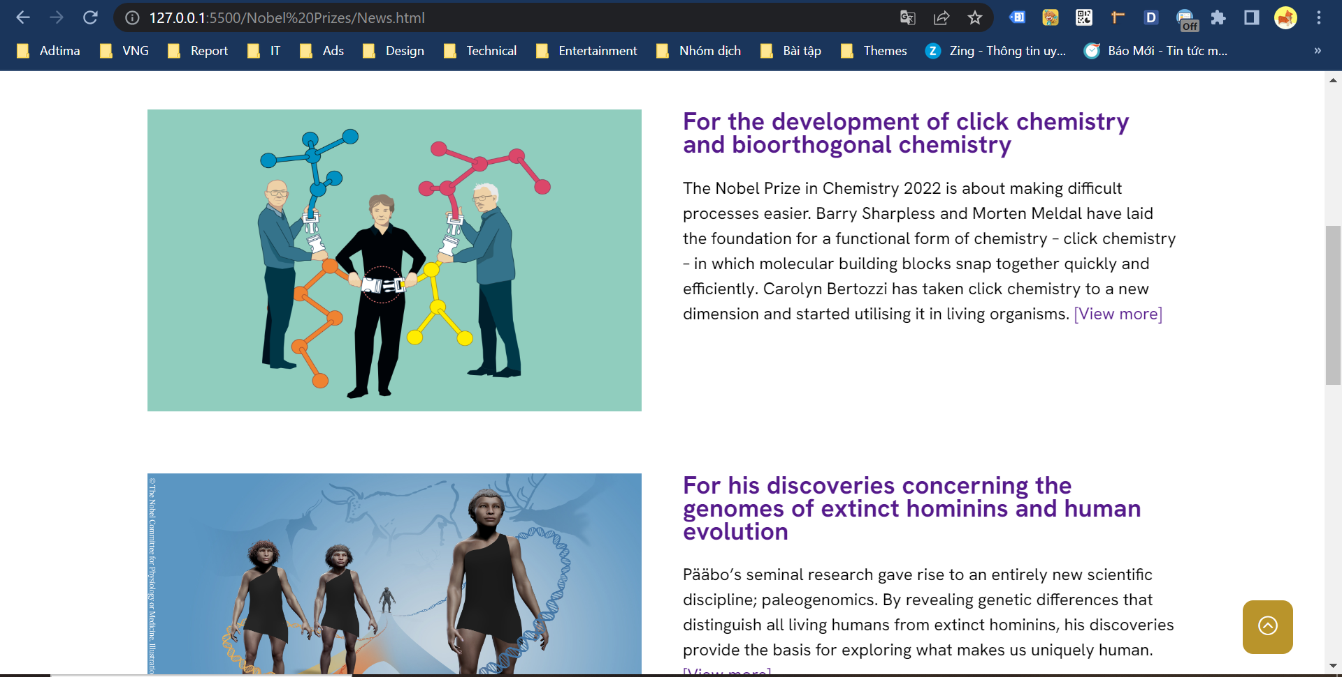

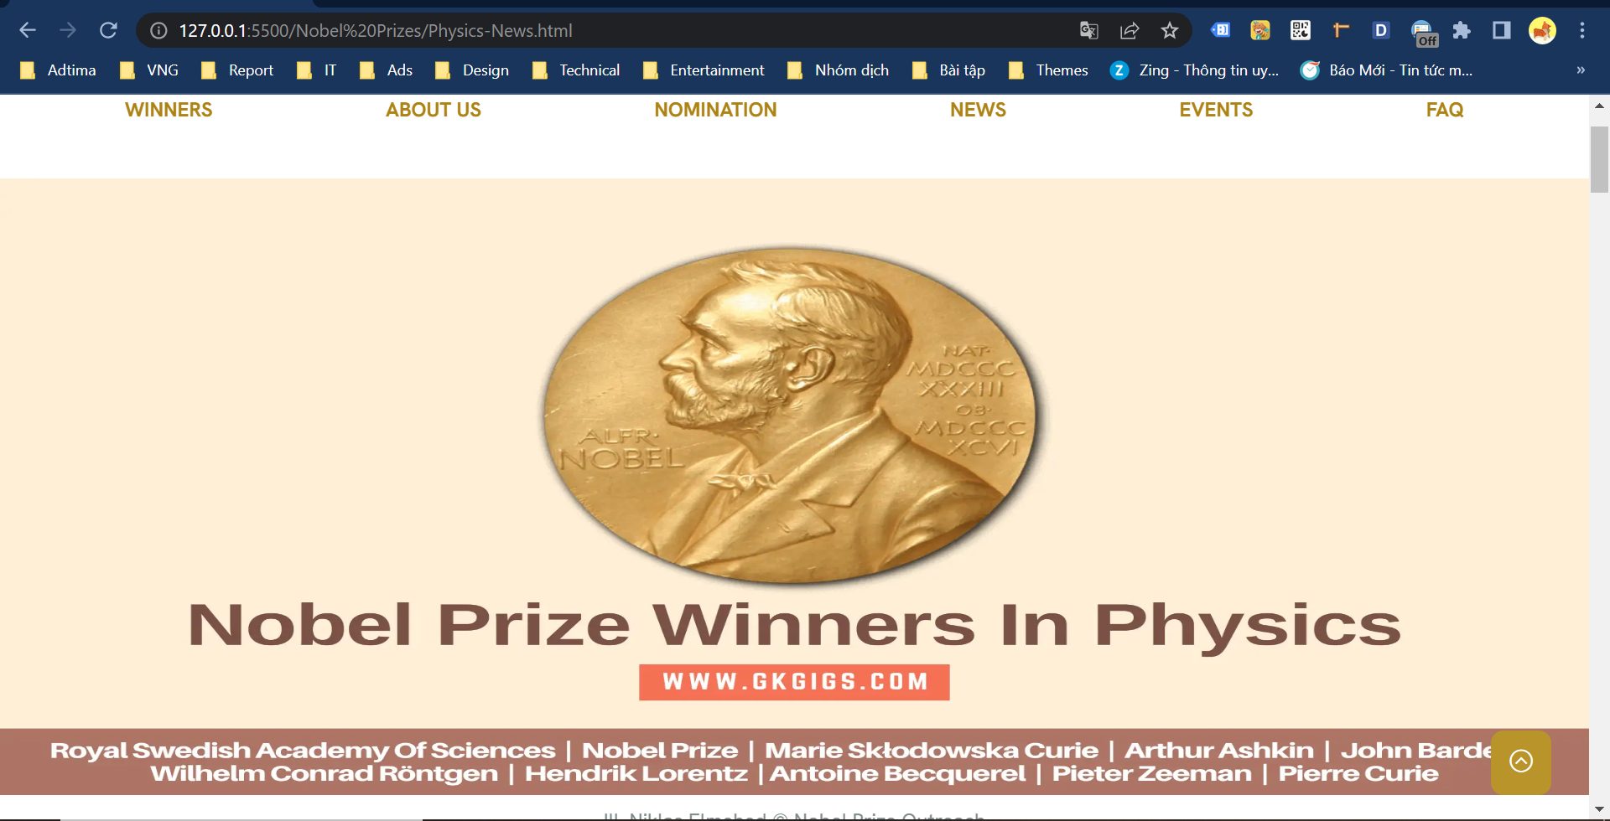

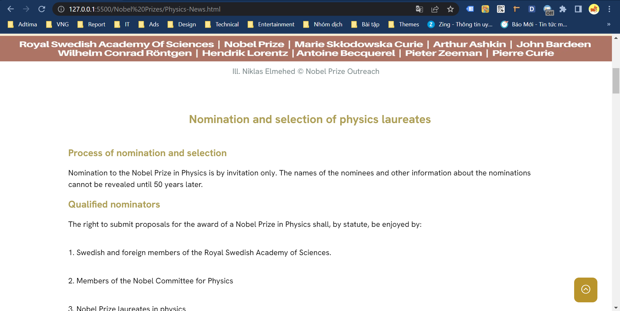

## 6. Events

a) Description

- This page displays events information.

b) Screenshot

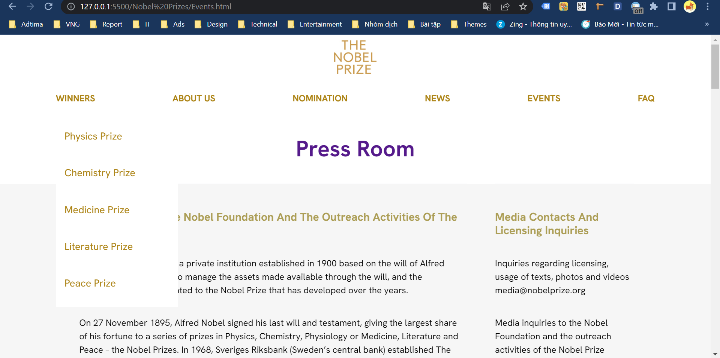

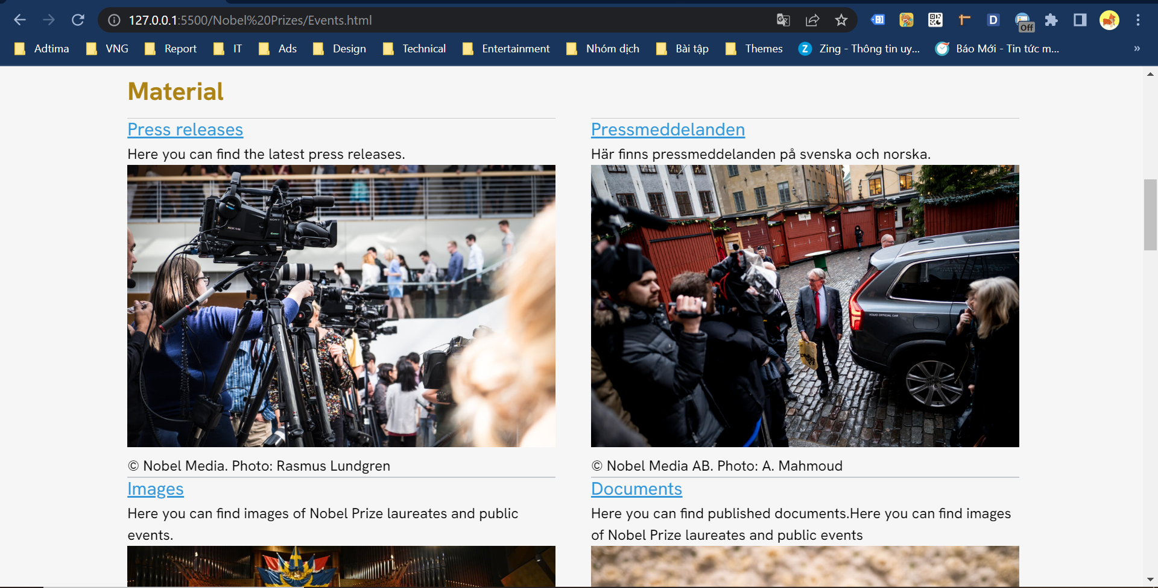

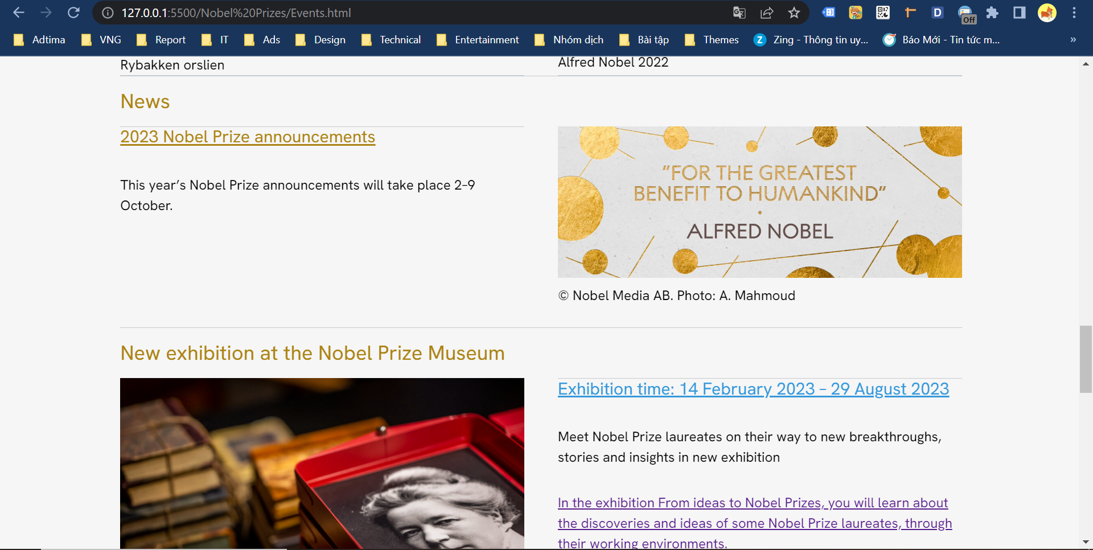

## 7. FAQ

c) Description

- This page displays information: Warranty terms, information, review about product.

- User can download product data.

d) Screenshot

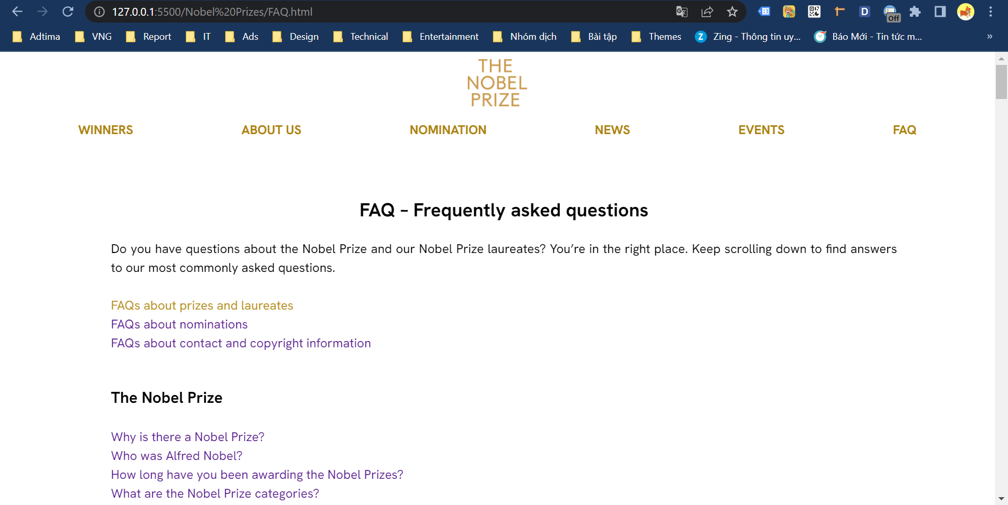

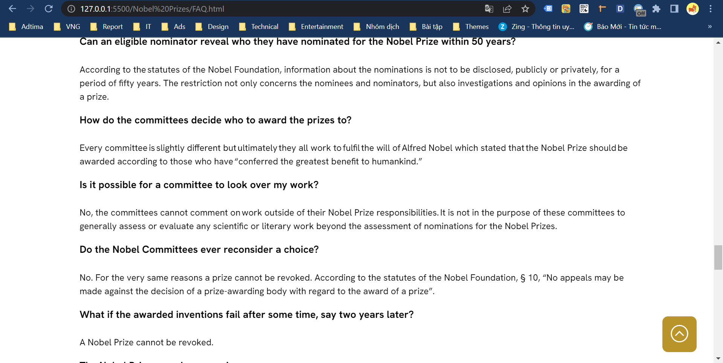

# JAVASCRIPT DESCRIPTION

## 1. Slider JavaScript

a) Description

This script used carousel to display the banners on the website.

b) Screenshot

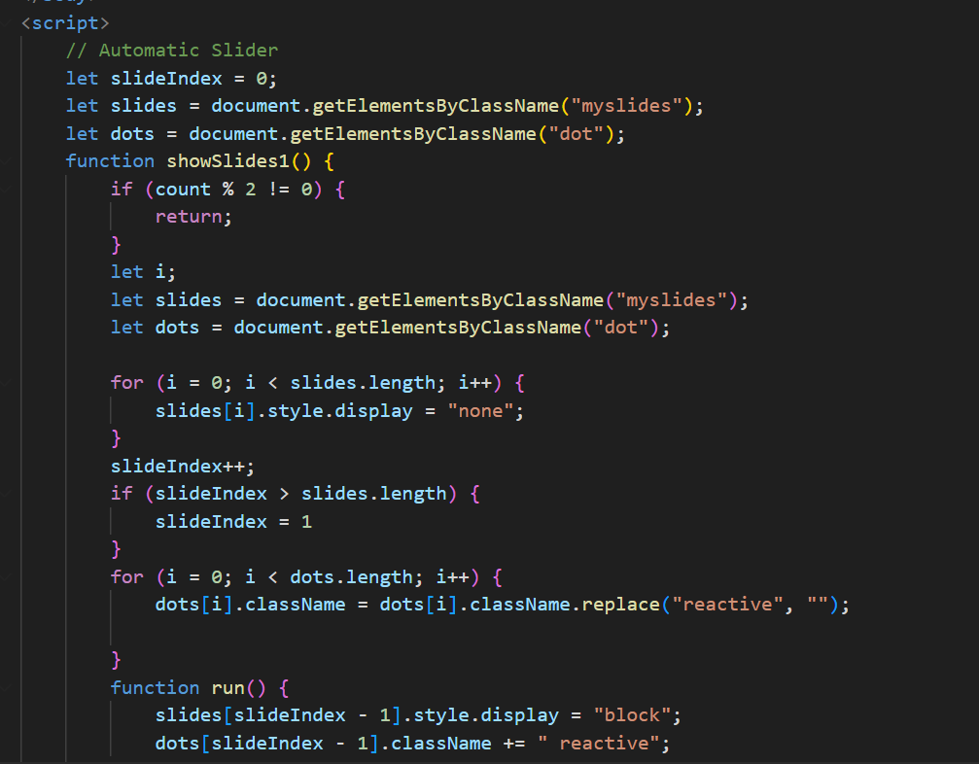

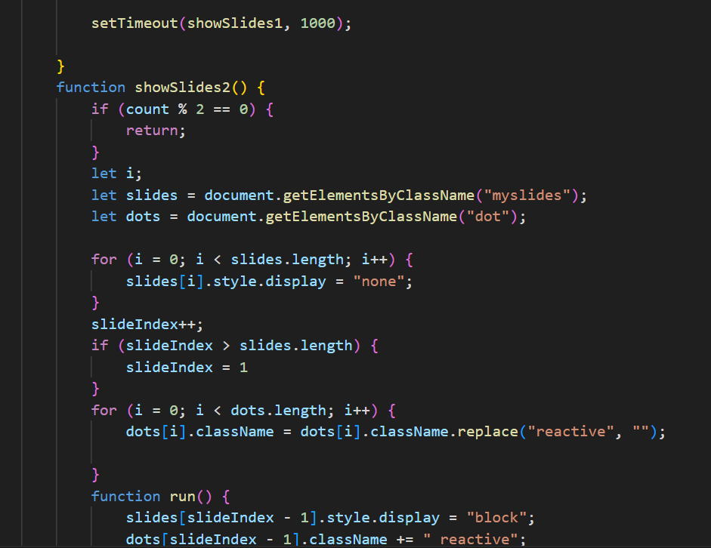

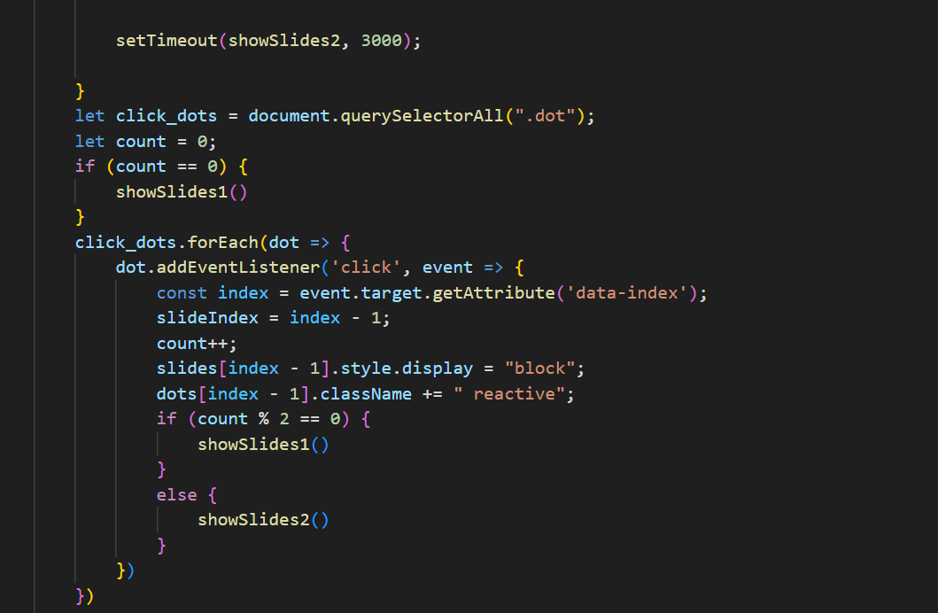

## 2. Email JavaScript

a) Description

This script is used to input a user's email.

b) Screenshot

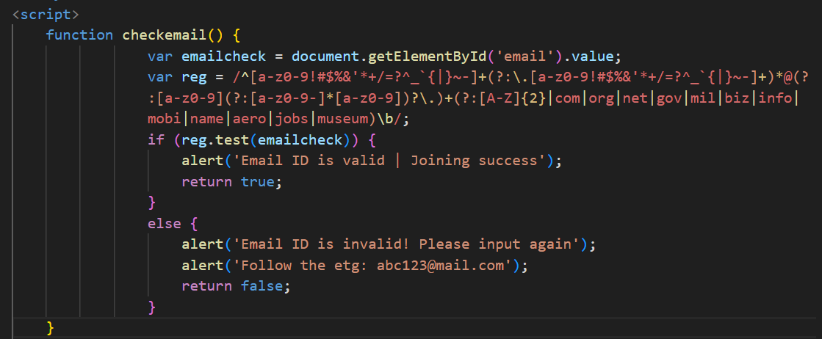

## 3. Contact Form JavaScript

a) Description

- Users can leave contact information for businesses to contact again

b) Screenshot

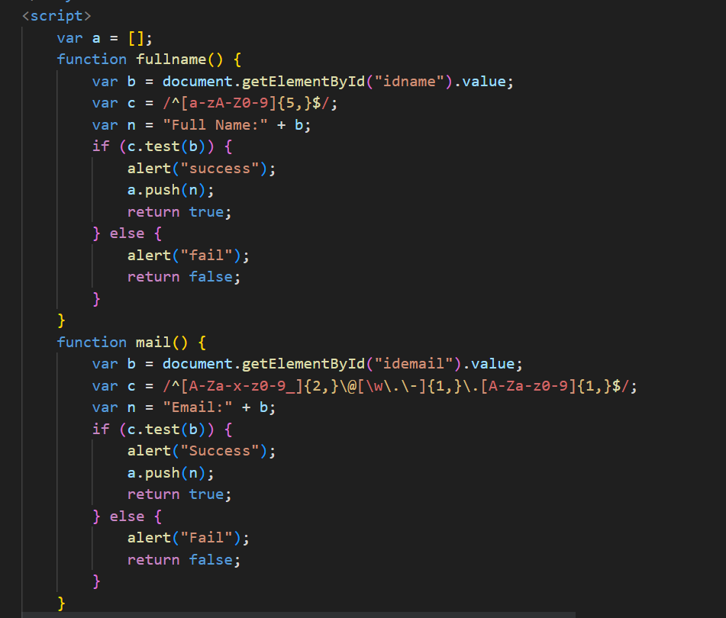

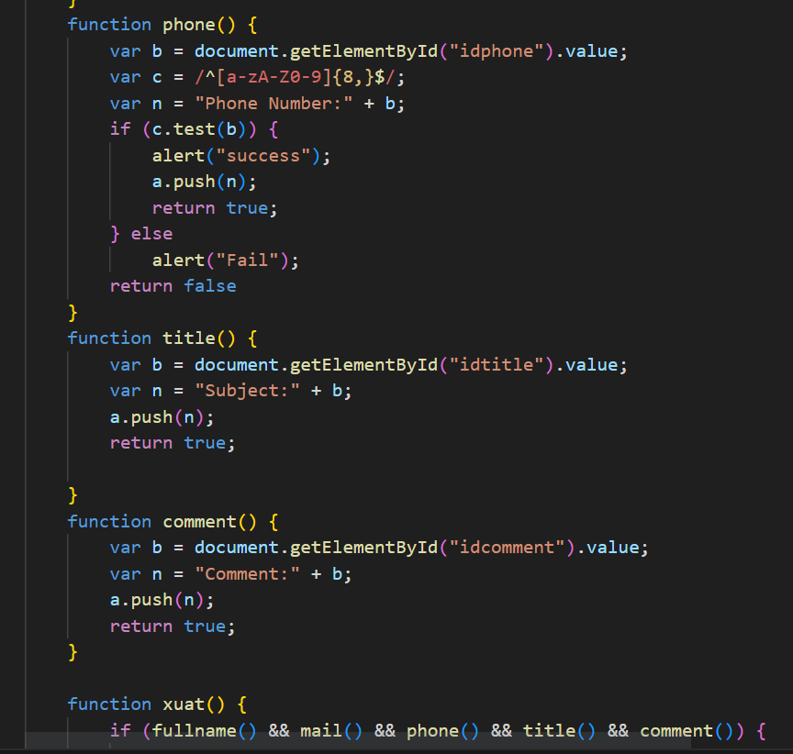

## 4. Register JavaScript

a) Description

This script is used for member registration to join the conference.

b) Screenshot

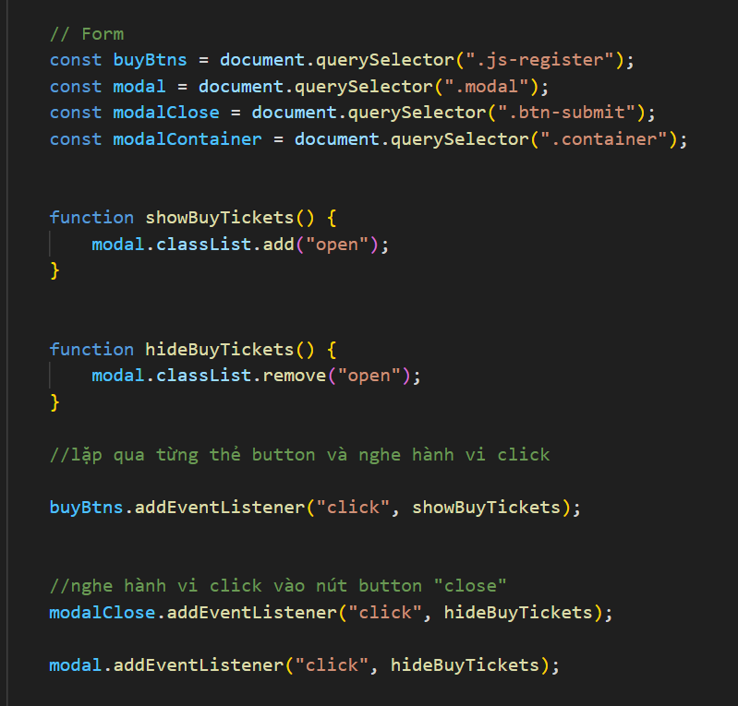

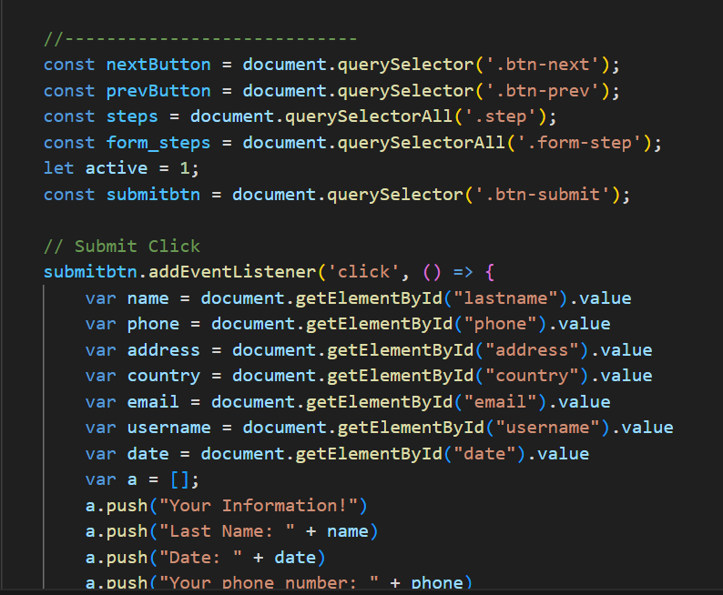



## 5. Button JavaScript

a) Description

This script help scroll to the top of the web page

b) Screenshot



# TASK SHEET REVIEW 3

|  |  |  |  |  |  |  |  |
| --- | --- | --- | --- | --- | --- | --- | --- |
| **Project Ref. No.:**  **eP/Advertisement Portal Management**  **System/01** | | **Project Title:** | **Activity Plan Prepared By:** | **Date of Preparation of Activity Plan:** | | | |
| **Sr.**  **No.** | **Task** | **Actual**  **Start**  **Date** | **Actual Days** | **Teammate Names** | **Status** |
| 1 | Home Page | Nobel Prize | Linh | 3/6/2023 | 1 | Linh | Completed |
| 2 | Physics Prize | 3/6/2023 | 3 | Huy | Completed |
| 3 | Chemistry Prize | 3/6/2023 | 2 | Linh | Completed |
| 4 | Medicine Prize | 3/6/2023 | 2 | Hoang | Completed |
| 5 | Literature Prize | 3/6/2023 | 2 | Hoang | Completed |
| 6 | Peace Prize | 3/6/2023 | 2 | Hoang | Completed |
| 7 | Nomination | 10/6/2023 | 1 | Huy | Completed |
| 8 | About Us | 5/6/2023 | 2 | Linh + Hoang | Completed |
| 9 | News | 5/6/2023 | 1 | Linh + Hoang | Completed |
| 10 | FAQ | 13/6/2023 |  | Linh | Completed |
| 11 | Register | 5/6/2023 |  | Linh | Completed |
| 12 | Events | 10/6/2023 |  | Hoang | Completed |
| 13 | JavaScript | 3/6/2023 |  | Linh + Hoang + Huy | Completed |

|  |  |
| --- | --- |
| **Date:** | |
| Signature of Instructor:                    **Ms. Le Mong Thuy** | Signature of Team Leader:                    **Dinh Hoang Khanh Linh** |